**TNPortfolio Video Guidance**

In response to various questions from portfolio implementing teachers regarding uploading, deleting, and viewing student work artifact videos in TNPortfolio; the educator effectiveness has crafted this guidance document.

The following are guidelines for using videos as student work artifacts in the platform:

1. Supported file formats for videos

* mov- Apple QuickTime
* mpeg- digital Video Format
* mp4- Digital Video Format

1. File format considerations

* TNPortfolio platform will except .mov files for upload, however the platform is converting the .mov into a .mp4 file in the background. Therefore .mov files take longer to upload and may not appear in preview until 24 hours later.
* The following message may appear in the preview window while the platform is converting the .mov file into a .mp4

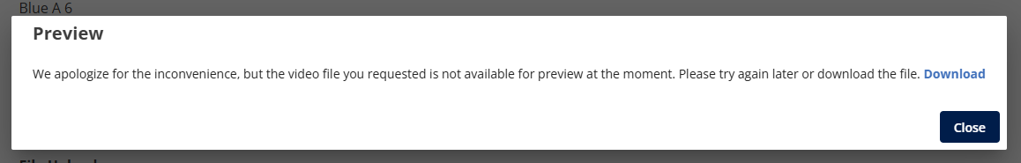

1. File size considerations

* It may take several minutes to upload videos that are longer than 5 minutes. A blue spinning circle will appear while the video is uploading.

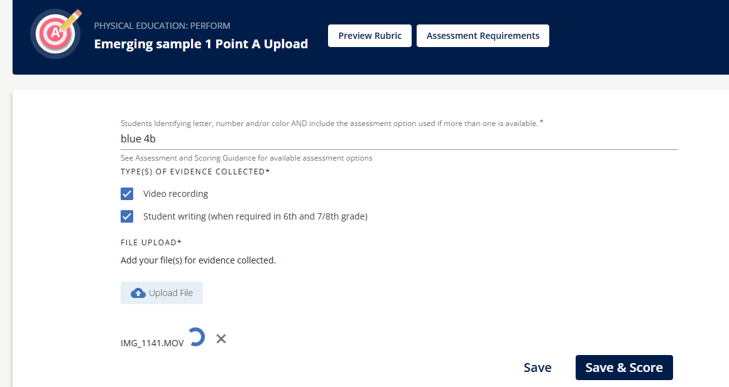

* The ideal file size is 1GB, but the platform will upload files as large as 5GB. If your video is over 5GB, consider editing it into separate smaller videos. The platform allows multiple videos to be uploaded for student samples.

1. Recording setup

* Test camera and microphone before actual recording to ensure the student is both visible and audible on the video.

1. Saving the video to your device

* Videos must be uploaded to the platform from files stored on a computer/laptop.
* The platform does not support direct uploads from Google Drive.
* Teachers can store work in Google Drive and then download it to their computer/laptop when they are ready to upload it into the platform.

1. Upload file

* Click the blue upload file button and select the video file from your device.
* After the video file is selected, it may take a few minutes for the upload spinning circle to appear. This is common when the file is large.

1. Preview video

* Once the upload is complete, click on the file name in blue to preview the video in the platform. Keep in mind .mov files may take up to 24 hours to appear in preview.

1. Removing videos

* Once a video is uploaded, a teacher may choose to remove the video by clicking the X next to the file name.

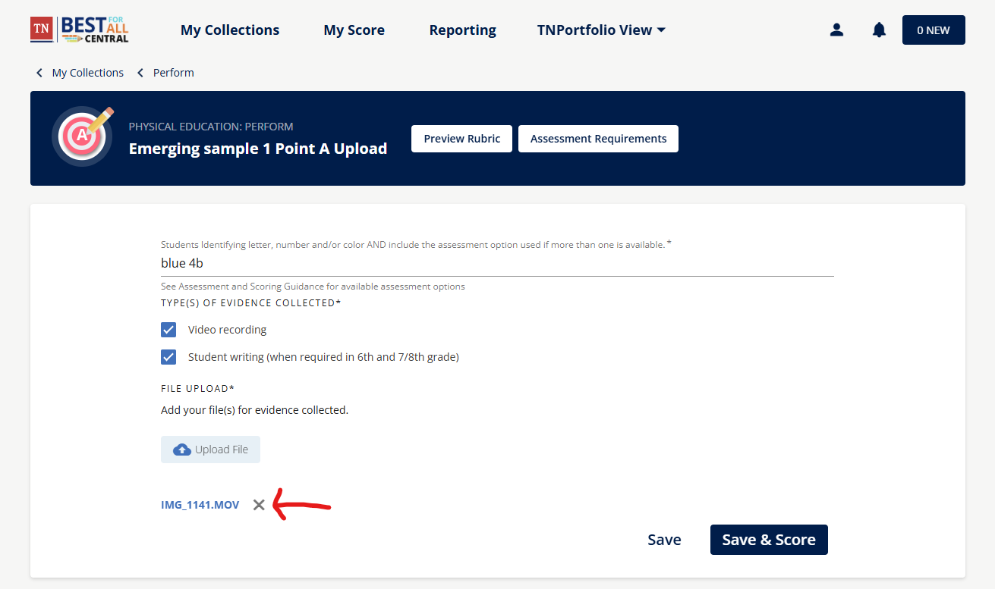

* In order to protect teachers from incomplete portfolios, the platform is designed to require a file upload before this section can be saved.
* If a student work sample is uploaded and then deleted, the platform may require a new student work sample to be uploaded to click Save.

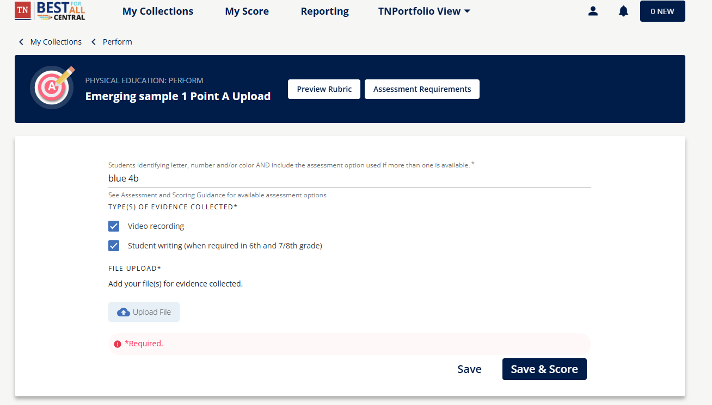

* If a new student work file is not uploaded, the previous file will continue to appear and not be deleted.

1. Samples uploaded to TNPortfolio between January 30th, 2025, 2:30 PM CT and February 5th, 2025, did not upload to the platform correctly. The issue in the platform has been resolved. Please remove any samples from this time window and re-upload them to ensure accuracy. Check preview to ensure you can view your samples.

1. Images formated as .docx files are not showing in preview, if you have uploaded a .docx file and cannot see it, remove it. Save it as a pdf file and reload it to ensure the peer reviewer can view it. We are working on this issue with the development team.
2. For support, email [Portfolio.Questions@tn.gov](mailto:Portfolio.Questions@tn.gov)